Příloha č. 4 ZD - Annex 4 of the Tender Documentation (courtesy translation – for information only)

CHMI current computing system and infrastructure

The current computing system
The current technical environment of the Computer Centre of CHMI consists of the following main components:
- The supercomputer NEC SX-9, 2 nodes interconnected by the IXS Crossbar, each node is equipped by 16 vector processors and by 1 TB memory;
- The shared disk file system with a storage capacity of 118TB;
- Support workgroup servers NEC EXPRESS 5800 140Rf-4;
- The backup server Sun V490 + Qualstar TLS 46120 AIT 5 tape library and the archiving system Oracle Sun SL3000 tape library (software pro backup: Legato Networker; software for archiving: SAM-FS);
- Database servers Oracle T5 cluster ;
- SAN-technology disk storage NetApp ;
- the telecommunication computer cluster (NetApp FAS 3210);
- the local network based on Cisco Gigabit Ethernetu. (limited to 10G)

CHMI Computer Room
The Computer Room of CHMI is located in the ground floor of the building close to the building exit. The room is split to two parts. The new System of the Phase B will be located in the room B. The ceiling is 3.5 m high. The loading capacity of the doubled floor is 5 kN/m². The narrowest door frame along the access route is 111 cm wide and 198 cm high.
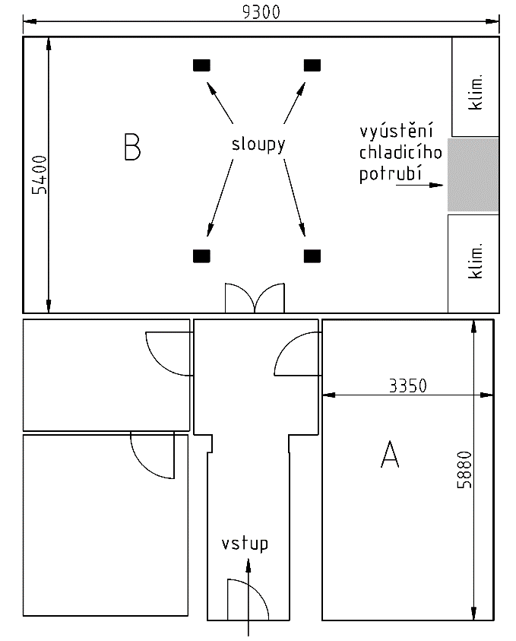

The so-called migration System of the Phase A will be located in the annex part of the computer room, denoted as A, next to the room B, see the sketch.

Conditioning units – by air
The computer room B is equipped by two air conditioning units HIMOD 50UA and the humidifying and the air-purification unit. Air is sucked in the upper part of the unit and after passing through the unit it is pumped under the doubled floor.
Parameters:
- explicit quantity of air 50 000 m³/h
- air cooling load by outside temperature 32°C 100 kW
The temperature in the hall is maintained from 20 to 21°C and the humidity is maintained from 45 to 55%.

Preparations for water based cooling of the computer system
For a water based cooling of the computer system, the following pipes shall be installed:
2x PE100 SDR11 DL 160x14,6 type, of 20m length about. There shall also be a low-voltage cable (1-CYKY 4x10mm2) to feed chiller ventilators, a water supply pipe (1x PE100 32 x 4,4 mm) and a communication cable (TCEKEZY 24P) to monitor the chillers.
Pipes and cables shall be laid down from the computer hall (room B) to the basement of new cooling devices (next to the current chillers in the park). This basement (10,70 x 6,80 m in horizontal, with support walls of 2,0 m height at maximum) shall accommodate a new technology to cool the computer system. Pipes shall be used upon the delivery of the new computer system.

Electricity
The electrical power supply network in the CHMI site is standard 3x 220/380V, 50 Hz(±1%), 3 + PEN. In case of electric supply interruption the Diesel Electrical Aggregate (DEA) is automatically activated with the start-time 60 seconds.
The electrical supply capacity backed up by DEA available to the new System is 160 kVA. No major upgrade of DEA is planned for next 5 years.

